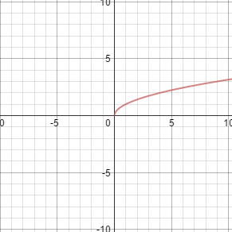

Domain: (0, $∞$) Range: (0, $∞$)
- $x=30.6 and x=-32.6$

- No Solution
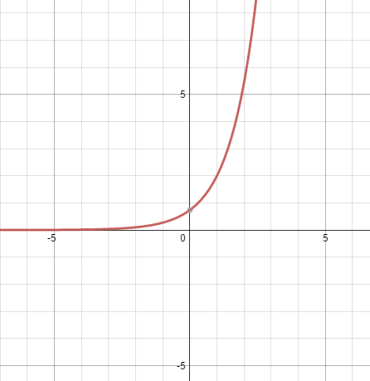

Domain: All Real Range: y>0
$x$-int: None $y$-int: (0, 0.736)

- Domain: $h≥0$
Range: $0<P≤101.3$

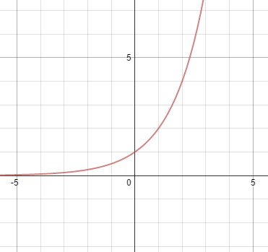

Domain: All Real Range: $y>0$
$y$-intercept: $(0,1)$
What family of functions is this? Exponential
What is the maximum value over the domain $-2≤x≤2$? 4

- $f\left(x\right)={4(2)}^{x}$
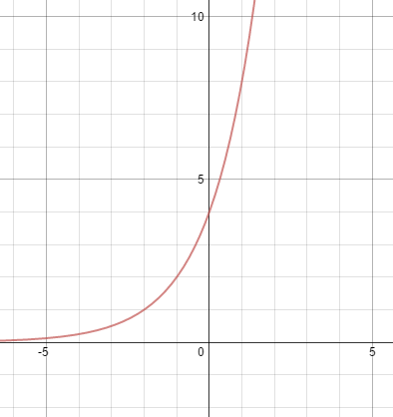

$f\left(x\right)={4(2)}^{x-3}$
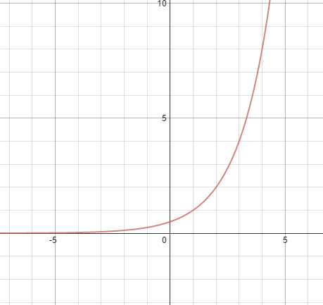

$f\left(x\right)={(-3)(2)}^{x}+1$
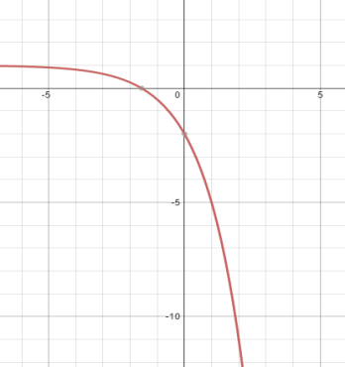

- Decay, percent change = 67%
Growth, percent change = 75%
Decay, percent change = 20%

- Growth: $b>1$
Decay: $0<b<1$

- $P=250{\left(1-.03\right)}^{x}$
$P=215$

- $T=12,000{\left(.75\right)}^{n}$
- $A=amount after t years$
$P=principal or initial amount$
$r=annual percentage rate$
$t=time in years$

- $\$4788.87$

- $\left(\frac{5}{2},177147\right)$
- $x=9.3$

- $e^{3.9}=50$
$2^{-3}=\frac{1}{8}$
$a^{x}=b$

- $y=\log_{2}64$
- $x=-.333$

- $x=128$
$x=4.561$

- $0.967 grams$
- Logarithmic Function
$f(x)=\log_{b}x$

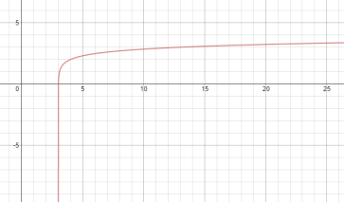

Domain: ($3,∞$) Range: ($-∞,∞)$
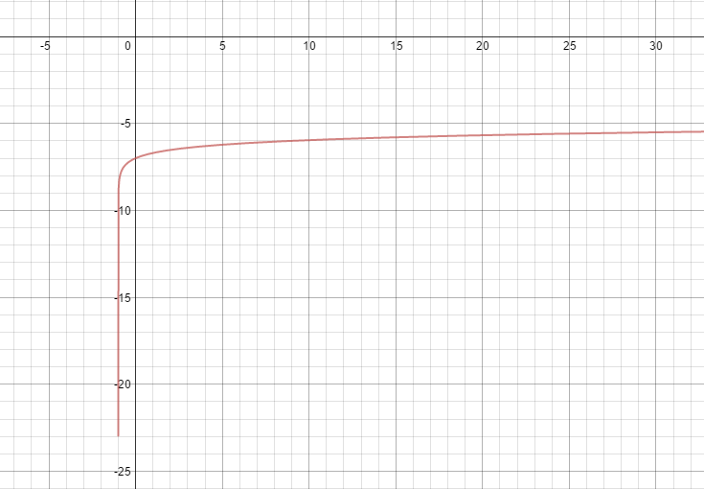

Domain: (-1, $∞$) Range: ($-∞,∞)$
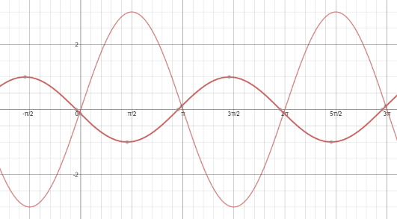
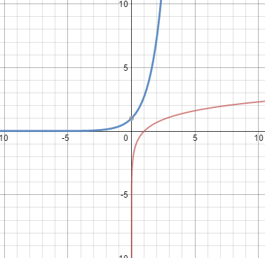

$f\left(x\right)=lnx$
Domain: (0, $∞$)
Range: ($-∞,∞)$
y-int: None
x-int: (1,0)

$f\left(x\right)=e^{x}$
Domain: ($-∞,∞)$
Range: (0, $∞$)
y-int: (1,0)
x-int: None

- $sinθ=\frac{\sqrt{3}}{2}$
- $170°$
$-190°$
$\frac{5π}{4}$
$\frac{-3π}{4}$

- Amplitude = 50
Period = $\frac{2π}{3}$
Vertical translation = Up 1

- Domain = all reals
Range $-0.001≤θ≤0.001$

- $\frac{8}{17}$

- $\frac{2π}{3}$radians

- Domain: all real numbers
Range: $-4≤y≤6$
Period: $π$
Amplitude: 5
$$y=5\sin\left(2x\right)+1$$

- $\frac{-\sqrt{3}}{2}, \frac{\sqrt{3}}{2}, 1$

- .1517
- $\frac{1}{4}, \frac{1}{6}$
- $\frac{3}{5}$

- $\frac{7}{10}, \frac{1}{10}, \frac{9}{10}, \frac{4}{5}, \frac{3}{7}$

- Arithmetic sequence.
$$a_{1}=8, a_{n}=a_{n-1}+4$$
$$a_{n}=4n+4$$
$$204$$
260

- Geometric sequence.
$$a_{1}=-1, a_{n}=-3a_{n-1}$$
$a_{n}=-1{(-3)}^{n-1}$
$1,594,323$
$-4921$

- $a_{n}=-2n+10$
- The 9th summer

