Pre-Calculus Quiz 3.1 to 3.3 Review Name

Evaluate the function at the given value. Round to three decimal places.

$f\left(x\right)=-0.5∙{8.5}^{x}$ when $x=3$ $f\left(x\right)=14e^{0.25x}$ when $x=20$

Graph each exponential function. Label two points and the asymptote.
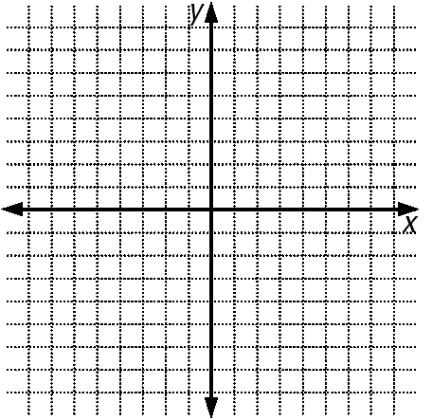
$y=3^{x}$ $y=3^{x}-4$

Use the one-to-one property to solve each equation for x.

$6^{x}=1296$ $e^{3x+1}=e^{2x-3}$

Write each equation in logarithmic form.
$4^{3}=64$ $6^{-3}=0.00463$

Write each equation in exponential form.
$\log_{7}{2401}=4$ $\log{0.0001}=-4$

Simplify each expression:

$\ln{e^{40x}}$ $\log_{7}{1}$

Graph each logarithmic function. Label two points and the asymptote.
$y=\log_{2}{x}$ $y=\log_{2}\left(x+3\right)$

Use your calculator to evaluate each of the following. Round to four decimal places.
$e^{8}$ $\log{25}$

$\log{0.314}$ $e^{-\frac{1}{3}}$

Evaluate the expression using the change-of-base formula. Round answers to three decimal places.

$\log_{16}{130}$ $\log_{3}\left(\frac{25}{37}\right)$

Expand each logarithmic expression.

$\ln\left(\frac{15x^{2}}{3y^{0.5}}\right)$ $\log_{4}{22x^{9}}$

Condense each logarithmic expression to the logarithm of a single quantity.

$3\log_{3}{x}+\log_{3}\left(y-7\right)$ $-4\log{x}+\log{6}$

