Radical/Rationals

- Ms. Henderson asked her students to graph $f\left(x\right)=\sqrt{x}$. What does this graph look like?
What is the Domain and Range?

- What is the solution of $2\sqrt[3]{{(x+1)}^{2}}+1=21$ (rounded to the nearest tenth)?

- Where does the following line intersect the line y = 3? $f(x)=x+ \sqrt{-11-3x}$

Exponential/Logarithmic

- Graph the following:$y= 2e^{x-1}$ Identify the domain, range, x-intercept and y-intercept.

- At a constant temperature, the atmospheric pressure p in Pascal’s is given by the formula
$p=101.3e^{-0.001h}$, where h is the altitude in meters. What is an appropriate domain and range for this function?

- Graph $f\left(x\right)=2^{x}$. Identify the domain, range, and $y$-intercept. What family of functions is this? What is the maximum value over the domain $-2≤x≤2$?

- Graph the following:
$f\left(x\right)={4(2)}^{x} f\left(x\right)={4(2)}^{x-3} f\left(x\right)={(-3)(2)}^{x}+1$

- Are the following functions growth or decay? What is the percent increase or decrease?
Sketch a graph.
- $y=(6){\left(\frac{1}{3}\right)}^{x}$
- $y=(2){(1.75)}^{x}$
- $y=(9){(0.80)}^{x}$

- Consider the following exponential equation: $y=(a){(b)}^{x}$
For what values of b is this a growth function?
For what values of b is this a decay function?

- An initial population of 250 sparrows has been decreasing at a yearly rate of 3%. Presuming that the population continues to decrease at the same rate, write and solve an equation that could be used to determine the population 5 years after the initial count was made.

- Hudson High School bought a $12,000 sound system for its gymnasium. The value of this sound system depreciates at a rate of 25% annually. Write an equation that can be used to predict what this system will be worth after n years.

- Given the continuously compounded interest formula$A=Pe^{rt}$, explain what each variable represents.

- If you invest $4000 into a bank account with an interest rate of 3% and the interest is compounded continuously, how much will be in your account after 6 years?

- At which point do the graphs of $y=3^{4x+1}$ and $y=9^{x+3}$ intersect?

- Solve for x: $64=(2){(1.4)}^{x+1}$

- Rewrite the following logarithms into exponential form.
$ln 50=3.9$ $\log_{2}\frac{1}{8}=-3 \log_{a}b=x$

- Rewrite $64=2^{y}$ in logarithmic form.

- For the equation $\log{5}- \log{50}=3x$ , what is the value of $x$ ?

- Solve for the value of x.
$$\log_{2}x=7 \log_{3}150=x$$

- Radium has a half-life of 13 years. If the initial amount of radium is 200 grams, how much will remain in 100 years?

- What type of function is the inverse of an exponential function?
Give the inverse for $f\left(x\right)=b^{x}$.

- Graph the function $y=\log\left(x-3\right)+2.$ State the Domain and Range.

- Graph the function $y=\log\left(x+1\right)-7$. State the Domain and Range

- Graph $f\left(x\right)=lnx$and its inverse. Identify the domain, range, $y$-intercept, and $x$-intercept for each.

Trigonometry

- Given: $cosθ=\frac{-1}{2}$ $sinθ>0$
Find sin$θ,$ using the Pythagorean Identity $\sin^{2}θ+\cos^{2}θ=1$

- Find an angle coterminal with $θ=1250°$ where $0°≤θ<360°$.
Find an angle coterminal with $θ=1250°$ where $-360°≤θ<0°$.
Find an angle coterminal with $θ=\frac{13π}{4}$ where $0≤θ<2π$.
Find an angle coterminal with $θ=\frac{13π}{4}$ where $-2π≤θ<0$.

- Consider the function$y=50\sin{3x}+1$. State the amplitude, period, and vertical translation.

- The sound wave for the note A above middle C can be modeled by the function
$y=0.001\sin\left(880πθ\right)$. Give the domain and range of this function.
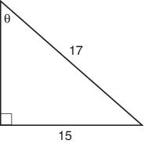
- Given the following triangle, find $cosθ.$

- If a unit circle is intercepted by a central angle measuring 120 ͦ, what is the length of the arc in radians?

- Graph $y=3sinx$ and $y=-sinx$ on the same graph. What do you see in the equation that causes the differences in the graph?

- Find the domain and range of the given sine function
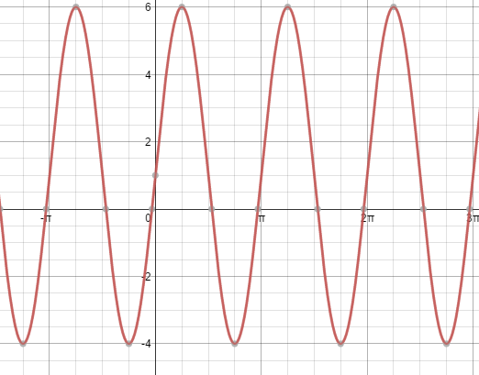
Find the period.
Find the amplitude.
Write a sine equation that represents the graph

- Evaluate the following using your unit circle.

$cos\frac{5π}{6}=$ $sin\frac{2π}{3}=$ $sin\frac{15π}{6}=$

Probability

- Mr. Romero wrote the names of each of his students on slips of paper and placed them
into a hat. He randomly removed two of the slips without replacement, and the students whose names he drew received a prize. If there are 18 girls and 12 boys in the class, what is the probability that Mr. Romero drew a boy both times?

- You roll a 6-sided die and flip a coin. Find the probabilities.
$P\left(roll an even number and flip a head\right)= _______________$
$P\left(roll a multiple of 3 and flip a tail\right)= _______________$

- Given the set of integers from 1 to 10, what is the probability of choosing an odd number or a multiple of 3.

- A survey was given on how much time students study in one week. Find the following probabilities if a student was chosen from the survey.
 | MALE | FEMALE
MORE THAN 5 HOURS | 150 | 200
LESS THAN 5 HOURS | 100 | 50

$P\left(student studies more than 5 hours\right)= _______________$
$P\left(student studies less than 5 hours and is female\right)= _______________$
$P(student studies more than 5 hours or is male)= _______________$
$P\left(student studies more than 5 hours given they are female\right)= _______________$
$P\left(student is male given they study more than 5 hours\right)=_______________$

Sequences/Series
- Determine if the following sequence is arithmetic or geometric. 8, 12, 16, 20, 24…
Write a recursive formula to model the sequence:
Write an explicit formula to model the sequence:
Find the 50th term:
Find the sum of the 1st 10 terms:

- Determine if the following sequence is arithmetic or geometric. -1, 3, -9, 27, -81…
Write a recursive formula to model the sequence:
Write an explicit formula to model the sequence:
Find the 14th term:
Find the sum of the 1st 9 terms:

- Jack is building a house of cards. The first level of the house has 14 cards, the second level has 12 cards, and the third level has 10 cards. If this pattern continues, which rule can be used to find the number of card, $a_{n},$ in any level, n, of the house?

- Two friends worked odd jobs together for extra money for the past four summers. The following table shows how much the friends earned over four summers. If the friends continue to earn money at this rate, during which summer will their total earned for all years be over $10,000. Solve using an appropriate equation.

SUMMER | FIRST | SECOND | THIRD | FOURTH
MONEY EARNED EACH SUMMER | $200 | $300 | $450 | $675
ACCUMULATED TOTAL EARNED | $200 | $500 | $950 | $1625

