Pre-Calculus Quiz 3.1 to 3.3 Review KEY
Evaluate the function at the given value. Round to three decimal places.
$f\left(x\right)=-0.5∙{8.5}^{x}$ when $x=3$ $f\left(x\right)=14e^{0.25x}$ when $x=20$
$f\left(3\right)=-307.063$ $f\left(20\right)=2077.784$
Graph each exponential function. Label two points and the asymptote.
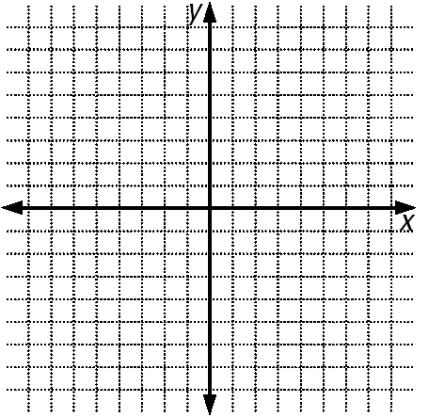
$y=3^{x}$ $y=3^{x}-4$

$\left(0, 1\right)$ $\left(0, -3\right)$
$\left(1,3\right)$ $\left(1,-1\right)$

asymptote asymptote
$y=0$ $y=-4$

Use the one-to-one property to solve each equation for x.
$6^{x}=1296 x=4$ $e^{3x+1}=e^{2x-3} x=-4$
Write each equation in logarithmic form.
$4^{3}=64$ $6^{-3}=0.00463$
$\log_{4}{64}=3$ $\log_{6}{0.00463}=-3$

Write each equation in exponential form.
$\log_{7}{2401}=4$ $\log{0.0001}=-4$

$7^{4}=2401$ ${10}^{-4}=0.0001$

Simplify each expression:
$\ln{e^{40x}}=40x$ $\log_{7}{1}=0$

Graph each logarithmic function. Label two points and the asymptote.
$y=\log_{2}{x}$ $y=\log_{2}\left(x+3\right)$

(1, 0) (-2, 0)
(2, 1) (-1, 1)
Asymptote @ x = 0 Asymptote @ x = -2

Use your calculator to evaluate each of the following. Round to four decimal places.
$e^{8}≈2980.9580$ $\log{25}≈1.3979$

$\log{0.314}≈-0.5031$ $e^{-\frac{1}{3}}≈0.7165$

Evaluate the expression using the change-of-base formula. Round answers to three decimal places.
$\log_{16}{130}=1.756$ $\log_{3}\left(\frac{25}{37}\right)=-0.357$

Expand each logarithmic expression.
$\ln\left(\frac{15x^{2}}{3y^{0.5}}\right)$ $\log_{4}{22x^{9}}$

$(ln{15}+2\ln{x})-(\ln{3}+0.5\ln{y})$ $\log_{4}{22}+9\log_{4}{x}$

Condense each logarithmic expression to the logarithm of a single quantity.
$3\log_{3}{x}+\log_{3}\left(y-7\right)$ $-4\log{x}+\log{6}$
$\log_{3}{x^{3}(y-7)}$ $\log{{6x}^{-4}}$

